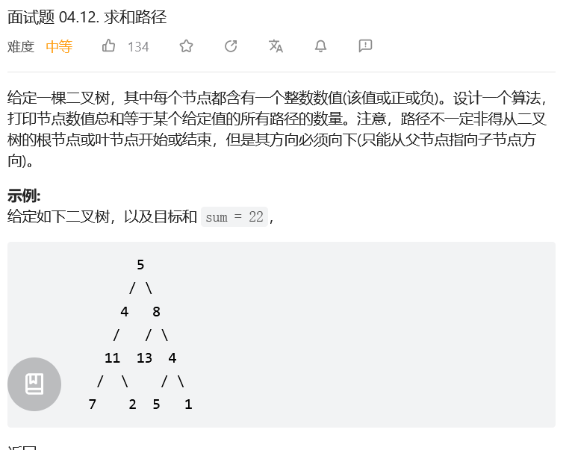

# Definition for a binary tree node.
# class TreeNode:
# def __init__(self, x):
# self.val = x
# self.left = None
# self.right = None

class Solution:
def pathSum(self, root: TreeNode, sum: int) -> int:
s = defaultdict(int)
res = 0
s[0] = 1
def dfs(root, t):
nonlocal res
if not root: return
t += root.val
res += s[t - sum]
s[t] += 1
dfs(root.left, t)
dfs(root.right, t)
s[t] -= 1
dfs(root, 0)
return res
